Bank System Documentation

# Team Shrek :

1. Венцислав Стайков - v.staykov
2. Борислав Живков - B.Jivkov
3. Ангел Венчев - AngelVenchev
4. Здравко Георгиев - roboky
5. Велин Ламбов - velin.lambov

# Project purpose:

We managed to create bank software. Using our product you have large selection of tools to manage your bank. I will describe some of the options of our Bank Engine. First it is really easy to add an office location into our engine. After that you can continue by adding employees working in that office, choosing from our list of employee positions. You can add as much offices as you like. After that it is time to manage your accounts. You can choose between deposit, loan and mortgage account.

There are two different account types to choose from based on their owner. First choice is standard Individual Account which requires you to create Individual Customer profile in our system. Second choice is for our Corporate Customers which, after providing us with their company credentials are able to take advantage of our special Corporate Accounts.

Finally you are able to keep logs of account activity and export it to text file. Our software is built in such way that it’s really easy to maintain and to add new functionalities.

Thank you for using our software.

# Class Diagram:

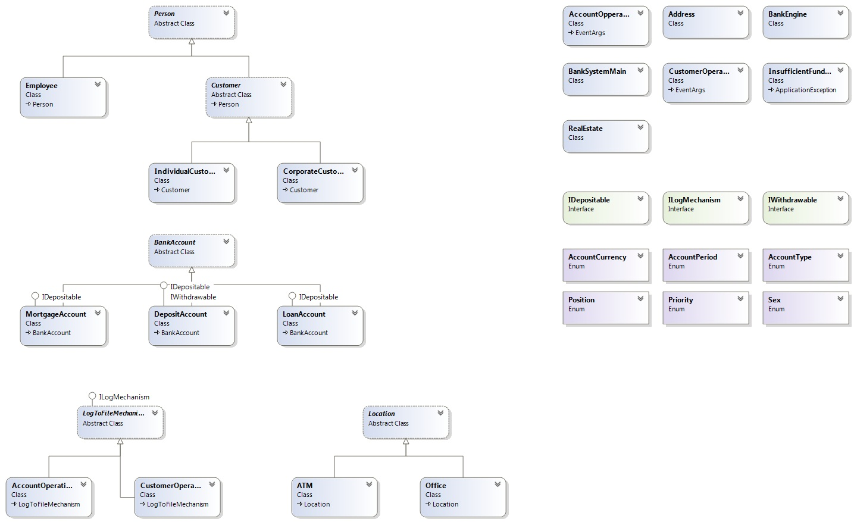

# Codeplex Repository:

<http://teamshrek.codeplex.com/>